**Application to Attend the 2023 PTK Regional and International Conventions**

While we would love to be able to take every interested member on this trip, we unfortunately have a limited number of seats so this application is designed to provide the advisors with some additional information about your interest in attending. More students will be selected to attend the Regional Convention than will be selected to attend the International Convention. For the Regional Convention, we are looking for enthusiastic and dedicated members who are both new to the chapter as well as those who have been active members during their time at MVCC. For the International Convention, since there are fewer spots available, we are looking for a mix of those who have served the chapter at high levels in addition to those who show promise and interest in becoming chapter officers next year. Of course, if you fit the criteria, you may certainly apply to attend both! All members interested in attending International Convention must have completed at least level two of Competitive Edge prior to April 1st (getanedge.ptk.org).

Please submit this application along with the trip deposit ($10) to Liz Doherty in ACC102 (Career Center) by Friday, February 24th at 12noon to be considered. Please note that if you are selected for International Convention you will need to pay an additional $40 beyond your deposit of $10 ($50 total) before the trip. The cost for attending Regional Convention is $10. If the cost feels prohibitive please come and talk with an advisor as we wouldn’t want that to be the reason someone missed out on this opportunity. Travel will be booked for selected students immediately so please only submit an application if you are interested and able to attend. All students who apply will receive an email the following Monday letting them know if they’ve been selected.

Name: ____________________________________

M#: _____________________ Date of birth: _________________________

Gender Identity: _____Who are you comfortable sharing a hotel room with? Men / Women / Men & Women

MVCC Email: ____________________________@student.mvcc.edu

Graduation Semester: _____________ Semester Inducted into PTK: _____________

Which convention(s) are you interested in attending? Regional International Both

Date Comp. Edge Level Two completed: ____________ Highest Level of Comp Edge completed: _______

Why do you want to attend this convention and what does it mean to you to represent our chapter there?

If you are a continuing member, what chapter activities have you been involved with? If you are a new member, how do you plan to be involved in future chapter activities (including why you’d want to be a chapter officer, if applicable)?

**2023 Spring PTK Regional Convention**

The New York Regional Convention is an opportunity to meet students from chapters all over New York State and to learn more about the hallmarks and opportunities within Phi Theta Kappa. Students will hear speakers, attend workshops, enjoy fellowship events, and have the opportunity to run for regional officer. If you are considering running for an office in our chapter for the 23-24 year attending the convention is not necessary but can be a great way to learn more about PTK. Additionally, chapters receive awards for their work in 2022.

The Regional Convention will be held at Monroe Community College, March 17th-19th!

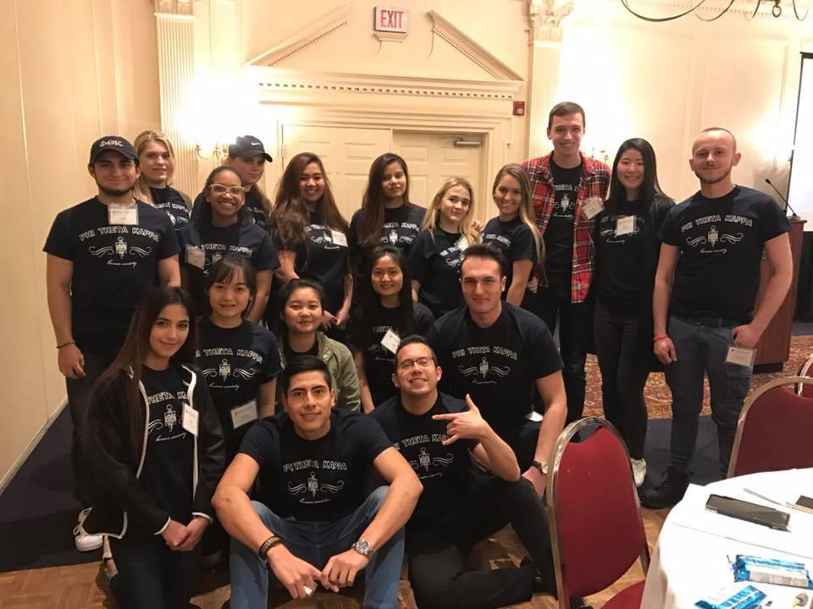Students are responsible for meeting at the college at the designated departure time (early afternoon on Friday, March 17th). We will then travel together to Rochester. All meals and hotel accommodations (double rooms) at Doubletree are included. Students are required to pay a $10 non-refundable deposit toward their trip.

As you will be representing MVCC and our chapter, your attire should reflect that (jeans/khakis and sweater/polo shirt/dress shirt, etc.). We will wear our MVCC chapter shirts on Friday night of the conference. There is a pool and a fitness center at the hotel.

The convention activities start around 8:30am and end with a social that runs 9pm-11pm. You are expected to participate in all activities and at least the first hour of the social.

All PTK events are drug and alcohol free. You will be asked to sign a code of conduct and provide some emergency medical information prior to leaving on the trip. It is also your responsibility to work with you instructors about any classes or assignments you will miss for this trip. Students will be asked to write and/or share about their trip experience with the chapter upon returning to campus.

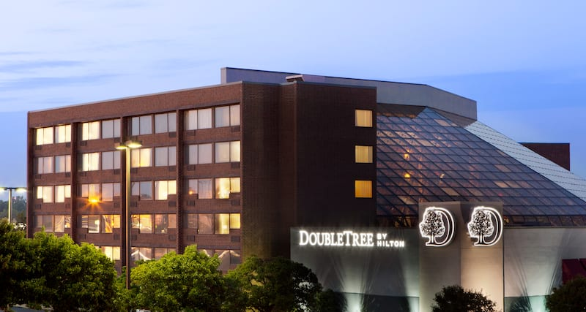

**2023 PTK International Convention**

The International Convention is an opportunity to meet students from chapters all over the world and to learn more about the hallmarks and many opportunities within Phi Theta Kappa. Students will hear speakers, attend workshops, visit the marketplace, talk with senior colleges, enjoy fellowship events, and experience some of the local attractions. The convention also includes the election of new international officers and presenting of many awards recognizing the achievements of chapters from 2022.

The International Convention will be held Columbus, OH April 20th – April 23rd. You can read more about it on the website – catalyst.ptk.org.

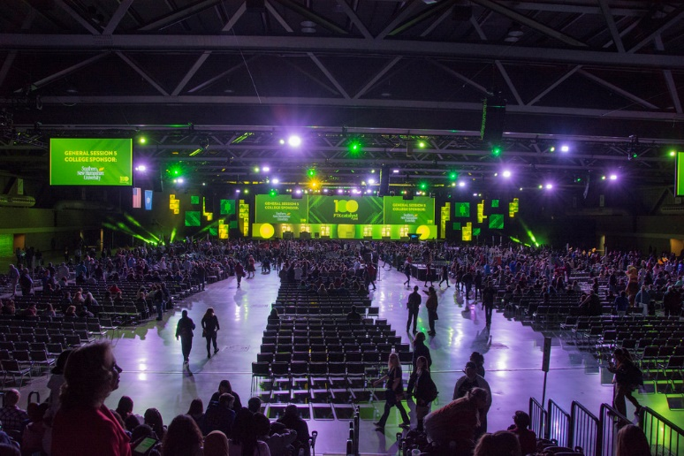Our chapter will be traveling by chartered coach with other chapters from upstate New York, leaving early on the morning of April 20th and returning in the evening on April 23rd. Students are responsible for meeting the group at the Utica campus at the designated time. Your transportation, hotel accommodations at Hilton Columbus Downtown (double rooms), and convention registration are included. Students will also be given a stipend to use toward meals not included in the convention. Students are required to pay a $50 non-refundable deposit toward the trip.

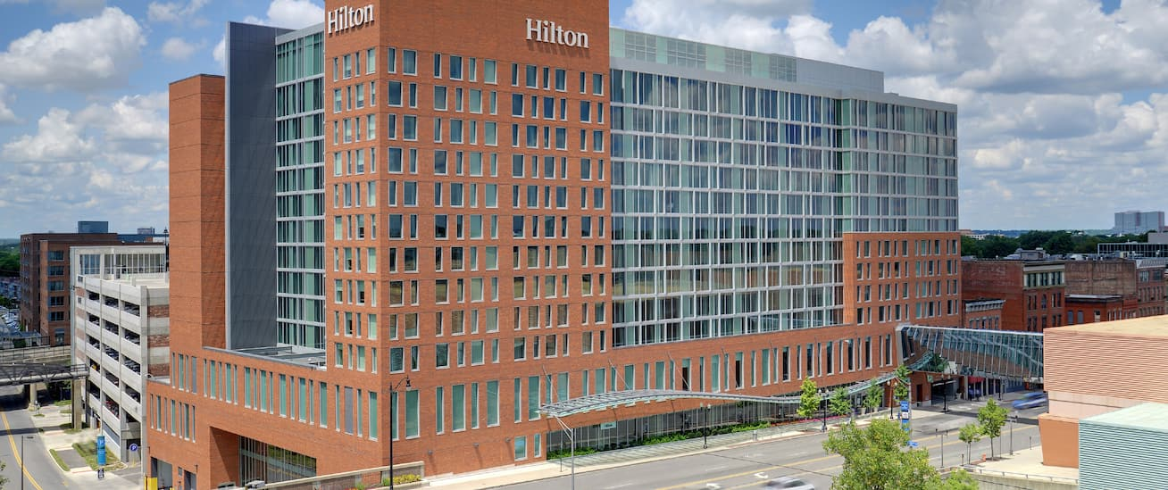As you will be representing MVCC and our chapter, your attire should reflect that. There is a formal gala on Saturday evening so please bring appropriate attire (ties and jackets for gentlemen, professional dresses or suits for women). There is a pool, Water Park, and a fitness center at the hotel.

Convention activities start around 8:30am and end later in the evening and you are expected to participate in all convention activities. There is some downtime to explore the local area and as a chapter we will have some planned outings to dinner and such.

All PTK events are drug and alcohol free. You will be asked to sign a code of conduct and provide some emergency medical information prior to leaving on the trip. It is also your responsibility to work with your instructors about any classes and assignments you will miss for this trip. Students will be asked to write about their trip experience in a trip journal and share it with the chapter upon returning to campus.