**MVCC Student Employment Supervisor Manual**

The purpose of this manual is to provide Mohawk Valley Community College Student Employment Supervisors with information regarding student employment opportunities, programs and standard procedures. Our goal is to have the employment process run smoothly and efficiently for each supervisor and student employee. This process starts with giving supervisors the help, support and resources they need, including:

* The Student Employment Supervisor Manual
* Supervisor Training every August
* Support from the Human Resources department when posting positions in Cornerstone
* Guidance and support at any time with any Student Employment issue

The Student Employment Supervisor Handbook is updated as needed and stored as a PDF on the Student Employment website. If you print a copy, please check the Student Employment website periodically for updates. If you cannot find what you are looking for, please contact the Career Development Center or Human Resources for assistance.

Student employment can be a high impact practice for student success that is a transformational learning experience for students. Additionally, work experience in college is often considered the number one factor in finding postgraduate employment. Some students qualify for the Federal Work Study program and others work on campus as Student Assistants.

The Mohawk Valley Community College Student Employment Program is intended to:

* Provide students with financial support for doing worthwhile work.
* Meet the needs of the college and other employers to perform day-to-day operations.
* Offer students valuable learning experiences to complement college and career goals.
* Help students develop good work habits and a positive attitude toward work.
* Prepare students for life beyond college.

Role of the Supervisor

Connecting Students and Jobs

Posting a Position

Finding Job Applicants

[Hiring a Candidate(s)](#_Hiring_a_Candidate(s))

Training

Part-Time Employee Payroll Schedule

Contact Information

# Role of the Supervisor

The supervisor is critical to the quality of work and learning that takes place on the job. Supervisors provide the training, guidance, and instruction that student employees need to be successful. Supervisors serve as role models for students; demonstrate good work habits, the value of doing work well, and the importance of accepting the responsibilities of employment.

**Assignments**

Identify and anticipate the department’s needs related to student employment. Develop a strategy for finding and hiring the right student employees. Assign student employees jobs that are necessary to the department’s operation. Help students to understand their roles and encourage them to become increasingly involved and to accept additional responsibility.

**Onboarding and Training**

Proper orientation to the job is essential and should be conducted for all new student employees. Develop a well-planned training program to ensure that student employees have the information and skills to do their jobs.

**Policies and Expectations**

Establish internal policies and clearly communicate expectations to ensure that each student employee understands the rules. Talk with each student in person to explain any performance issues and discuss ways the student can improve. If workplace performance does not improve, be clear of possible consequences, such as, changes to their job, decreased responsibility, reduction in hours, or even termination.

**Professional Relationships**

Encourage positive supervisor/employee relations with your student workers. This is intended to be an association of trust, respect, and a genuine interest in meeting mutual goals. Motivate the student to do the best job possible, inspiring both quality and quantity of work.

# Connecting Students and Jobs

Students find their own jobs; they are not assigned to specific positions. This gives each student the flexibility to find the type of position that best fits their interests, experience and class schedule each semester. It is the student’s responsibility to initiate the job search however the Career Development Center is happy to help any students with this process. Students can stop into the office in ACC102 or visit virtual walk-in hours through [www.mvcc.edu/careerevents](http://www.mvcc.edu/careerevents).

**Online Job listings**

Students are encouraged to start their job search by reviewing the online job listings, which are available on Handshake through the college’s website at [www.mvcc.edu/studentjobs](http://www.mvcc.edu/studentjobs). Positions are posted online to help supervisors reach a broader audience of qualified applicants and provide students with equal access to jobs. The major hiring period is at the beginning of the fall semester. Some students also change or begin jobs at the start of the spring semester and summer term. Fall semester jobs are posted one week before classes start. Occasionally openings are posted online at other times during the year.

# Posting a Position

Supervisors who need to hire student employees start by posting each open position on Cornerstone. Look for an email from the Human Resources department mid-July with details and dates for fall semester hiring.

**Submitting a Requisition Request**

1. From Cornerstone, click on Recruit then Requisition Requests

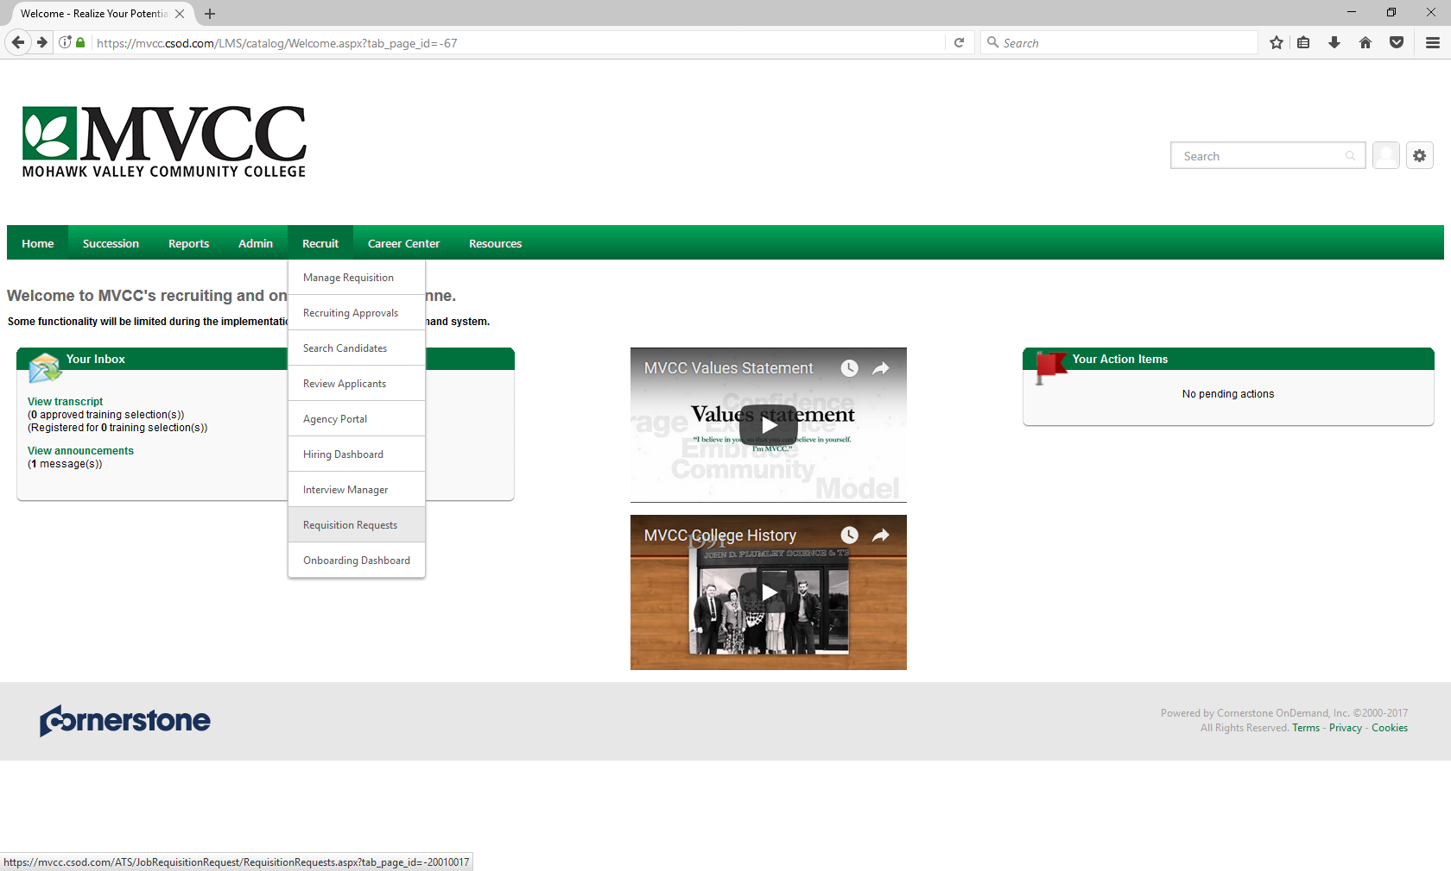

1. Click on the + sign to Create New Request

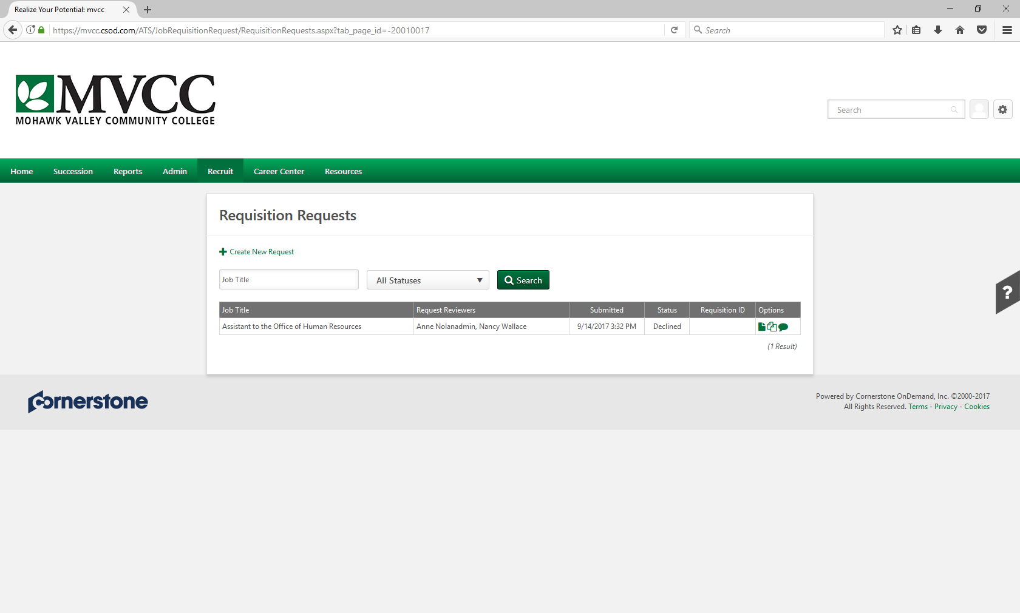

1. Click on the square next to ‘Job Title – Position’ to bring up the list of jobs. Search for your position. 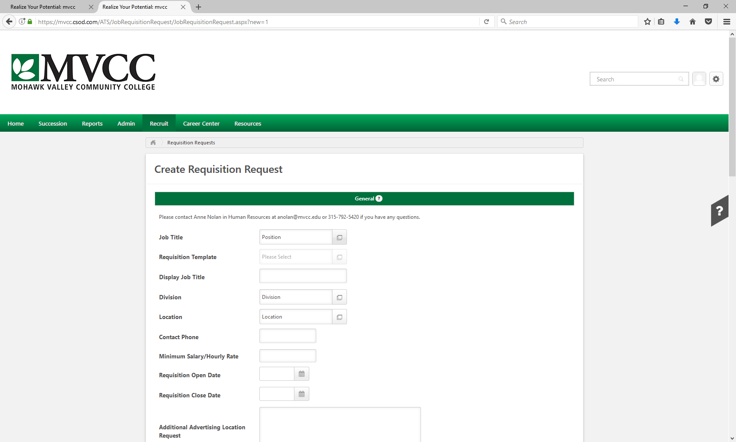

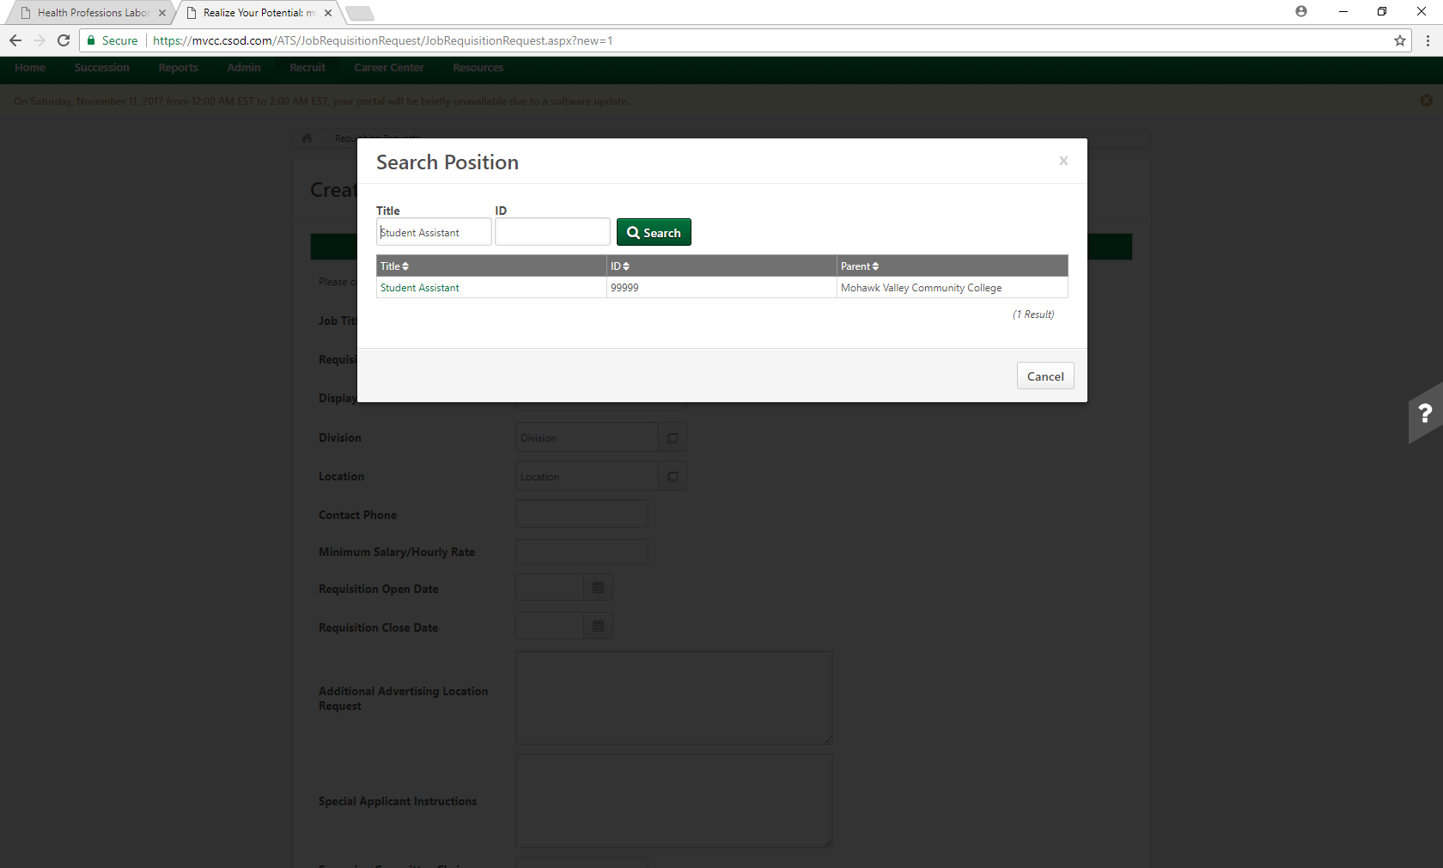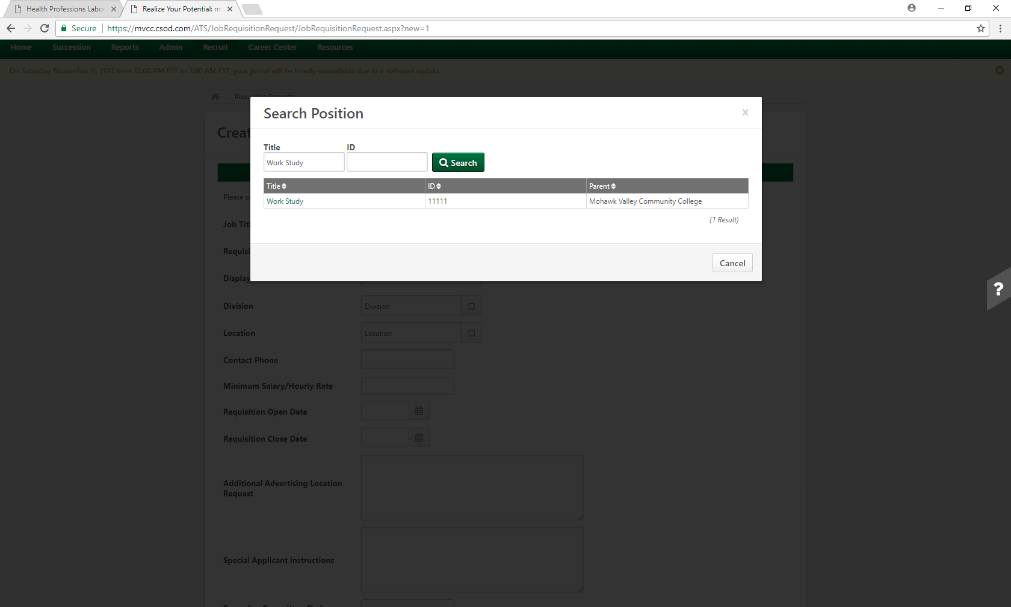If you are looking for a Work Study student, choose Work Study as the job title. If you are looking for a Student Assistant, choose Student Assistant as the job title.

1. Click on the Requisition Template to see if the position has a unique template. Most will be set to “Default Requisition Template”.

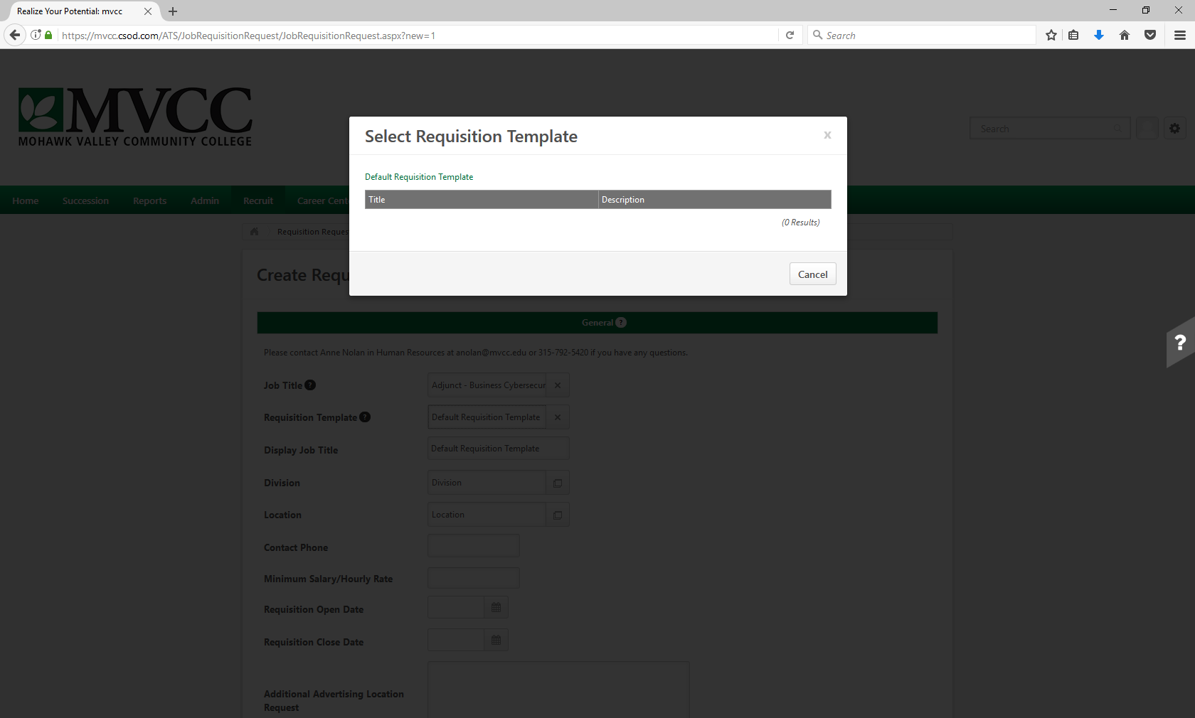

1. Fill in the remaining fields on the form.
2. Display Job Title – this is the job title that will appear on the career sites
3. For Division - under ID enter your 4 digit org code
4. Location - choose which campus
5. Enter the open date and close date
6. Enter your screening committee members (for Student Employment positions, there is no formal screening committee. Enter your name and/or your proxy’s name in the Screening Committee fields).
7. Enter the job description. (If you would like to see a prior job posting, contact Human Resources x5420 and we will pull the prior description for you to enter)
8. Enter qualifications (include any prescreening (disqualifying) questions you would like to include. We will add this to the appropriate section of the job posting.)
9. Enter the number of openings
10. Enter the target hire date

* Note: The Special Applicant Instructions and the contact phone have been populated for you. No further action is required for those fields.

1. After populating all the fields, click submit. Your request will be routed to Human Resources for review. We will complete the posting process and route to the hiring supervisor for approval prior to officially posting.

# Finding Job Applicants

Students interested in the position will submit an application through Cornerstone.

**Screening of Applicants**

The supervisor should review the applicant’s materials and whether they meet the minimum requirements needed for the position. It is up to the Supervisor to communicate with potential candidates through email or phone.

We ask that supervisors notify all applicants in a timely manner regarding dispositioning or interviewing. Students want to find jobs quickly during a short period of time each semester. If your position is their first choice, they may hold out to hear from you and lose other valuable opportunities while they wait. If an applicant is not a good fit for your position, tell them as soon as possible so they can continue their job search.

**Interviewing**

Supervisors are not required to interview applicants for student employment positions. However, interviewing is highly recommended. If you decide to interview applicants it should be consistently applied to all applicants for the same position to avoid the perception of unfairness in employment practices. Supervisors should develop a list of interview questions in advance. Ask questions that are job-related, behavior-based, and open-ended to get the most information from each applicant. Ask each applicant the same questions to evaluate each applicant consistently. Below is a list of possible interview questions.

Logistical Interview Questions

* How many hours per week do you want/are you available to work?
* Do you have other commitments that would affect your ability to do this job?
* Are you able to perform the essential functions of the job (with reasonable accommodations)?

Open-Ended Interview Questions

* How would you/a professor/a previous employer describe you?
* What are your career plans? How do you see this position enhancing your preparation?
* How is your college experience helping you prepare for your career?
* Why are you interested in this position?
* What do you know about our office/department?
* What did you learn in your last/any previous position?
* Describe the relationship that should exist between the supervisor and employee.

Behavior-Based Interview Questions

* What major problem have you encountered in the past and how did you deal with it?
* What positive qualities have you displayed in your present/previous position?
* Give me an example of a suggestion/decision you made that benefited your employer.
* Give me an example where you had difficulty communicating with someone and how you helped resolve it.

Questions you CANNOT ask

Questions regarding the subjects below are NOT allowed to be asked during an interview because they can be considered discriminatory:

* Race
* Color
* Sex
* Religion
* National origin
* Birthplace
* Age
* Disability
* Marital/family status

# Hiring a Candidate(s)

Once you have found the ideal candidate(s), you can offer them the position contingent on onboarding being completed with the Human Resources office and attending student employment orientation. Students can find the schedule of orientations on the website at [www.mvcc.edu/studentjobs](http://www.mvcc.edu/studentjobs).

Additionally, you will need to payroll authorization for each fiscal year.

**Payroll Authorizations**

<https://www2.mvcc.edu/wwwValidate/HRWEB/payrollauth.cfm>

*If you have any questions please contact Nancy Wallace (nwallace@mvcc.edu or ext. 5347) or Christina Dittmar (cdittmar@mvcc.edu or ext. 5638).*

Here is a quick summary of some of the recent changes:

1. An M number is required on all payroll authorizations. If you do not have the M number for a new employee, please contact HR and this will be provided once all new hire paperwork has been completed. Please remember, all new hire paperwork must be completed before an employee starts work at MVCC.

2. A summary of the Account numbers is provided in the Instructions.

3. Radio buttons for you to select the location for the assignment. This will ensure that payroll charges are allocated to Utica or Rome appropriately.

4. Radio button for Work Study Student - Once the payroll authorization is approved through the initial process, it will be routed to the Financial Aid Office for review, approval and notification of the financial award before it’s sent to HR for processing.

Please enter ORG = 1502 ‐ ACCOUNT = 65200 for the Budget Line Number for Work Study Student positions – only.

5. Contact information for the employee completing the payroll authorization. This will allow us to follow up if there are any questions or we need additional information.

6. Payroll authorizations will need to be completed for all part‐time positions, except adjunct positions processed through FLAC.

7. Step by step instructions and examples to aid in completing the payroll authorization form. The instruction are posted on the Form page – right next to the payroll authorization link for quick reference.

A payroll authorization will be required for student assistant and work study positions. Please complete the payroll authorization for your student employees after your student employee completes all new hire paperwork with the Office of Human Resources. Please coordinate with our office to ensure your employee starts working after all new hire paperwork is complete.

*Please remember ‐ No employee should begin work until a copy of the payroll authorization form with all approvals has been returned to the department from Human Resources. Exceptions are substitute instructors or other temporary duties for employees already on the payroll.*

Detailed directions can be found here - <https://wwwsecure.mvcc.edu/human-resources/forms/Pay-Auth-Instruct.pdf>

**New Hire Paperwork**

If the student has never worked on campus, they will be required to complete a Form I-9 and Form W-4 as well. Students should be prepared to present proper documentation of their eligibility to work and earn a paycheck in the U.S. Specific requirements for these documents can be found on the website (<https://www.mvcc.edu/career/pdf/i-9-page3.pdf>). Additionally students must have a valid Social Security number on record with the college.

Once the student employee has completed hiring paperwork with the Human Resources office, you will receive notification via email that the new hire can being working. The student cannot begin working until this communication has been received.

**Time Sheets**

All students working at Mohawk Valley Community College are paid minimum wage and must record all hours worked online on their timesheet in SIRS. They will receive a paycheck twice per month for the hours they have submitted and approved. The payroll schedule can be found on the here.

**Web Time Entry Instructions for Approvers**

1. From any computer on the Internet, go to the college website at <http://www.mvcc.edu> and click on the Information & Registration SIRS button.
2. Click on the Login to Secure Area button.
3. Enter your SIRS ID and PIN and then click on Login. *If you do not know your SIRS login information or have forgotten it, please contact HR at 792-5636*
4. Click on the Main Menu tab: Employee
5. Click on the link: Time Sheet
6. In the Act as Proxy section: Select Self if you are the supervisor or select Supervisor name if you are acting as a Proxy for your supervisor.
7. Click on Select.
8. Select the appropriate pay period that you are approving time for and click on Select.
9. To view the details of a time sheet, click on the Employees name.
   1. Employees that have completed and submitted their time sheets for Approval will display in the Approved section.
   2. Employees that have not completed and submitted their time sheets for Approval will display in the Not Started or In Progress section.
10. Review each time sheet. Click Previous Menu to return to main screen.
11. Check either the Select All/ Approve or FYI checkbox or Return for Correction checkbox. Then the SAVE button.

NOTE: By clicking the Return for Correction box, it WILL NOT send the time sheet back to the employee. Rather, it rejects the time sheet and a paper time sheet submission MUST be processed through Payroll. The paper time sheet will need to be completed by the student.

**Hiring International Students**

International students are eligible to work at on-campus jobs. They are limited to 20 hours per week.

They need to apply for a social security number before starting their position. To get their social security number, they need a job offer letter that includes their job title. Then they will meet with the Coordinator of International Student Services for a letter to take to an appointment at the Social Security Office. Once they receive their card in the mail (this may take 2 weeks or so), they will submit it to HR to be inputted in Banner and they can begin work.

**ADA Accommodations**

Mohawk Valley Community College supports a workplace that is suitable and accessible for all staff, faculty, and student employees. Reasonable accommodations will be made for persons with temporary or permanent disabilities to allow for a fair and equal employment experience. This policy is based on the Americans with Disabilities Act (ADA), the Rehabilitation Act, and any applicable state laws. These regulations provide a comprehensive statutory and regulatory approach to eliminating discrimination against qualified persons with disabilities and entitle them to accommodations which assist them in meeting the essential functions of their positions.

MVCC is committed to evaluating and responding to requests for accommodation by following an interactive, confidential and individualized process as described in the ADA. If you are a student employee with concerns about accomplishing work tasks due to a disability, and are in need of an accommodation, or if you are a manager/supervisor who has received an accommodation request from a student worker/work study employee, please contact the Office of Accessibility Resources (OAR) to proceed. You may contact OAR through [oar@mvcc.edu](mailto:oar@mvcc.edu) or 315-792-5644.

**Summer Employment**

Students registered for at least 6 credit hours during the summer term are eligible to be student assistants. Any returning student who is not registered for summer classes is eligible to work during the summer as long as the student is pre-registered for the following fall semester but are not considered student assistants. In SIRS student assistant jobs will be labeled as an “S” position. When a position starts with “IN,” it is for a student summer position. During the summer, student employees are required to pay FICA (deductions FIO and FIM).

# Training

**Onboarding**

For each student employee to perform to the best of their ability, they will need to know the policies and procedures that exist. Start by helping each employee become familiar with their work environment and the work of the department. Identify training needs and ensure that both staff and student employees have the information and skills to do their jobs. Policies should be clearly communicated, preferably in writing, to every employee.

*Orientation to the Workplace*

Tour of the area:

* Bathrooms
* Water fountain
* Coat and book storage
* Entrances and Exits

Introductions to other employees:

* Co-workers (staff and students)
* Key personnel (Deans, Directors, etc.)

Tools of the trade:

* Supplies
* Copy machine
* Phones
* Computer

Office etiquette:

* Office opening/closing procedures
* Phone messages
* Relaying information to co-workers
* Mail distribution
* Visitor policy

Standards of employment:

* Confidentiality
* Dress code
* Expectations
* Schedules
* Absences
* Evaluations
* Pay increases
* Consequences of poor performance
* Continuation of employment

*Job Training*

Telephones:

* How to answer/transfer calls
* Voice mail system
* Office protocols
* Phone etiquette

Computers:

* Access codes
* Logging on
* Frequently used programs
* Policies for use

**Attendance**

Supervisors should establish acceptable standards regarding attendance according to the needs of their department and the job responsibilities of each student employee. Students are expected to adhere to the work schedule as assigned and keep supervisors advised in advance of their intention to work (or not) during each semester or break. If it is necessary to be absent from work, the student should notify the supervisor as soon as possible and prior to the beginning of the work shift. Supervisors should clearly communicate under what circumstances absences or tardiness are acceptable and what expectations their student employees must meet before risking reassignment or termination.

**Schedules**

Supervisors arrange work schedules that address their department’s needs while attempting to accommodate each student employee’s class and exam schedule wherever possible. Supervisors can expect each student employee to commit to the work schedule agreed upon, and to explain in advance any changes that will affect their availability. It is the Supervisor’s responsibility to ensure students are taking the appropriate breaks.

**Specific job responsibilities**

The supervisor should develop a comprehensive training program for all employees.

# Part-Time Employee Payroll Schedule

<https://www.mvcc.edu/human-resources/pdfs/payroll/FY22-pt-employee-calendar.pdf>

# 

# Contact Information

**Human Resources**

Nancy Wallace [nwallace@mvcc.edu](mailto:nwallace@mvcc.edu) 315-792-5347

Stephanie Bush [sbush@mvcc.edu](mailto:sbush@mvcc.edu) 315-732-5420

**Payroll**

Marissa Flo [mflo@mvcc.edu](mailto:mflo@mvcc.edu) 315-792-5670

Shaina Stafford [sstafford@mvcc.edu](mailto:sstafford@mvcc.edu) 315-792-5320

**Financial Aid (work study)**

Jessica Norris [jnorris@mvcc.edu](mailto:jnorris@mvcc.edu) 315-731-5796

**Career Development Center**

Kevin Siembab [ksiembab@mvcc.edu](mailto:ksiembab@mvcc.edu) 315-792-5502

Liz Doherty [ldoherty@mvcc.edu](mailto:ldoherty@mvcc.edu) 315-792-5377