**Downloading and Installing Read & Write Gold using a Take Home Code**

**WINDOWS ONLY**

1. Open your web browser and navigate to <https://www.texthelp.com/products/read-and-write-education/> .
2. Scroll down the page a bit and then click “Try Read&Write”.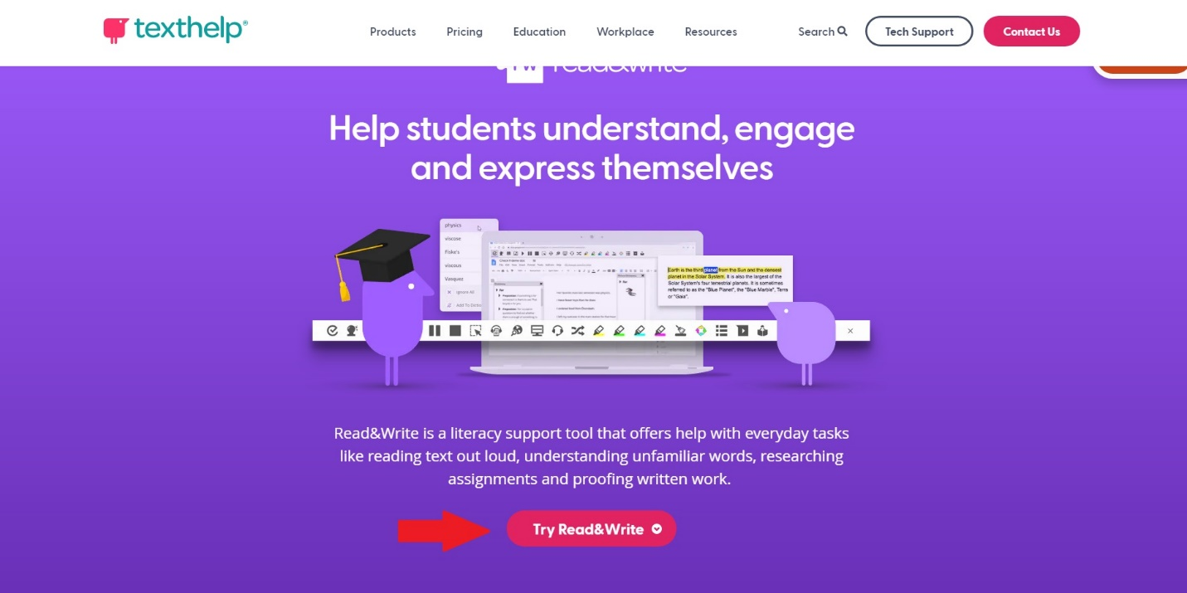
3. In the dropdown box that opens click “Windows [flag] US EN”. Once you click this option the software will begin downloading automatically.

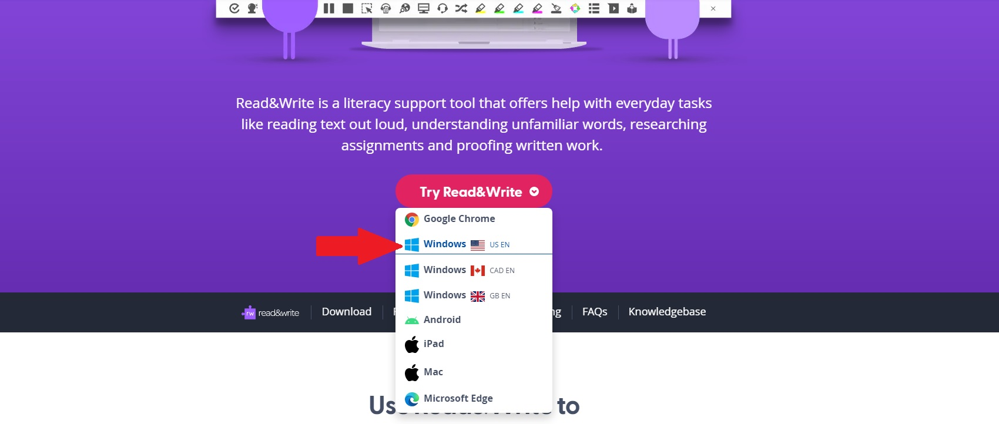

1. Navigate to wherever the software was saved, by default your “Downloads” folder and double click the “read&write” application file. The software will do some quick checks on your computer. If, after these checks, you are prompted with a message that states “Do you want to allow this app to make changes to your device?” Click “Yes”.
2. The software will automatically begin installing. Wait patiently until the window that says “Hi, almost ready to install” appears. On this window click the button that says “Accept and Install”. Wait patiently as the software installs. The install window will close automatically when the install completes.
3. Locate the icon that looks like a purple puzzle piece that should have been placed on your desktop by the installer. Double click the icon pictured below.

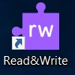

1. Double clicking the icon should have opened Read & Write. Somewhere at the top of your screen you will see a Read & Write tab like the one pictured below:



1. Click the purple puzzle piece with the “rw” in the middle that the arrow above is pointing to. A browser window will open that gives you the options displayed below. Select the option that says “Use Take Home Code”.

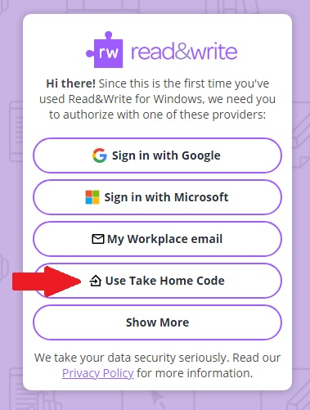

1. Enter the following code: **HUWRA2PQ4K** in the box provided and click “Sign In”:
2. The Read & Write software bar will open at the top of the screen and a message that reads “Thanks for signing in! You can now safely close this window.” Will be displayed. You can now close your browser window and are signed into Read & Write.

If you need assistance you can always call the OAR at 315-792-5644.