# How to make PowerPoint 2010 Accessible:

## Consider the following as you are designing the PowerPoint:

* Color contrast and font selection are important in making a presentation accessible to people who have low vision or color-blindness. Fonts should be large and easy to read, and there should be high contrast between the background and text.
* Use simple table or graphs with header information
* Include closed captions for any audio or video. To Caption use Sub-titling text add-in for Microsoft PowerPoint (STAMP) found here: <http://office.microsoft.com/en-us/powerpoint-help/sub-titling-text-add-in-for-microsoft-powerpoint-stamp-HA102540315.aspx?CTT=5&origin=HA102013555>
* Add Alternative Text to pictures

## After completing the PowerPoint presentation, follow the accessibility checker built into PowerPoint to provide inspection errors, warning, tips and “how to fix” accessibility results.

How to locate the PowerPoint accessibility checker

1. Click File and move to Info

2. Click on "Check for Issues" and move to "Check Accessibility"

1. Click File and move to Info
2. Click on "Check for Issues" and move to "Check Accessibility"

## The accessibility checker built into the program will explain how to fix the errors by clicking on the actual error and following the written directions.

The Accessibility Checker panel is on the right side of the screen. You can click on each error and at the bottom right of the panel specific directions on how to fix the error is provided.

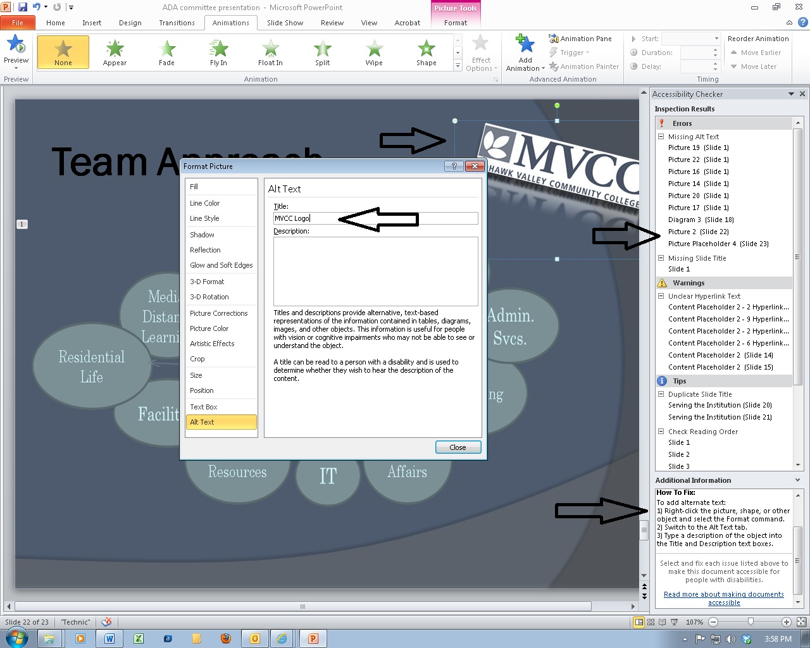

For more information on PowerPoint accessibility follow this link: <http://office.microsoft.com/en-us/powerpoint-help/creating-accessible-powerpoint-presentations-HA102013555.aspx?CTT=1>