# How to make a Microsoft Word 2010 Document Accessible

Like the spelling checker tells you about possible spelling errors, Accessibility Checker in Word, Excel, and PowerPoint tells you about possible accessibility issues in your Office file so you can fix these issues so someone with a disability can read and get to your content.

* Consider using the appropriate headings to allow screen readers to navigate directly to the content that a person wants. Ensure all heading styles are in the correct order (ex. In this document the title is “Heading 1” and the subsections considered “Heading 2”, Etc.).
* If you use additional audio components in a document, ensure that the content is available in alternative formats for users with disabilities, such as closed captions, transcripts or alt text.
* Objects that are not in line with text are challenging to navigate, and they may be inaccessible to users with vision impairment. Setting text-wrapping around objects to Top and Bottom or In Line With Text makes it easier for people with screen readers to follow the structure of your document.
* Extra spaces, tabs and empty paragraphs may be perceived as blanks by people using screen readers. After hearing “blank” several times, those users may think that they have reached the end of the information. Instead, use formatting, indenting, and styles to create whitespace.

## Click File and then Info

Click “Check for Issues” and then click on “Check Accessibility” and a section on the right side of the page titled “Accessibility Checker” will have the inspection results.

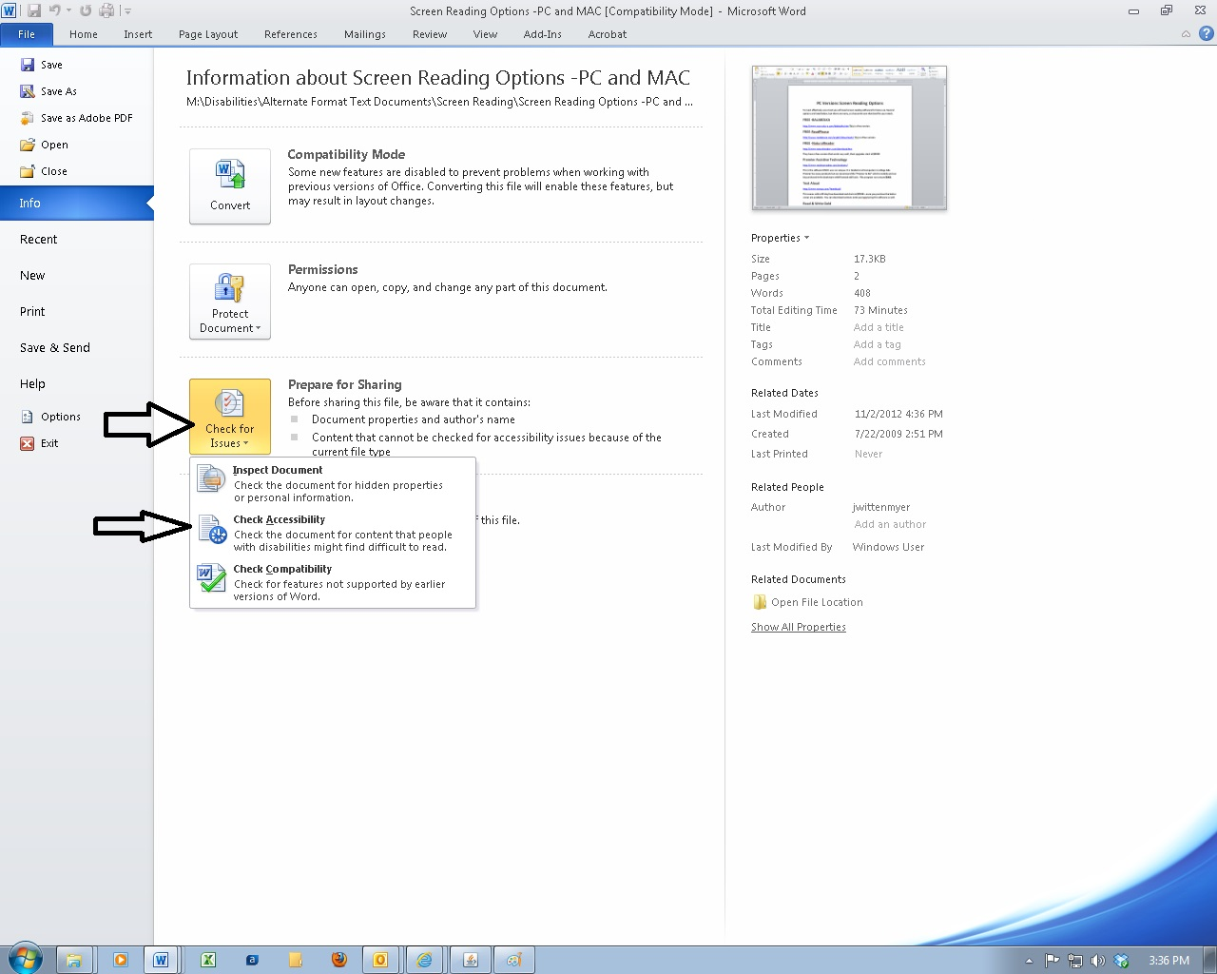

## How to fix issues in the Accessibility Checker

Click on the errors or Warnings and the directions of how to fix issues with accessibility are located on the bottom of the right section of the Accessibility Checker screen. See picture below:

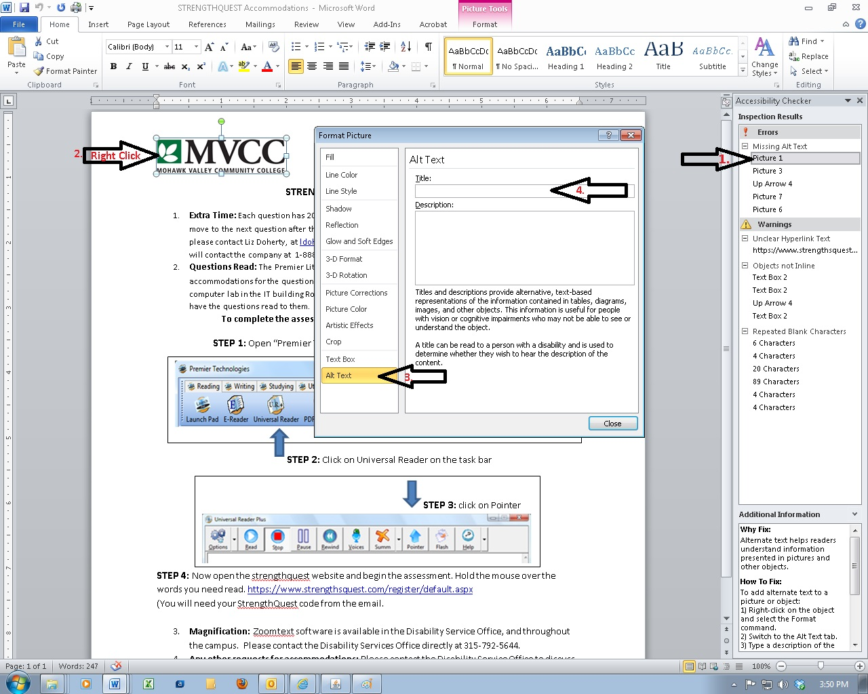

For more information, please go to this link: <http://office.microsoft.com/en-us/word-help/creating-accessible-word-documents-HA101999993.aspx#_Toc275414998>