Creating Accessible Microsoft Word 2016 Documents (Windows)

*Saved from:*

<http://www.mclennan.edu/tech-support/article/829/creating-accessible-microsoft-word-2016-documents-windows>

# Alternative Text for Images

***Images can be given appropriate alternative text in Word.*** This alt text is read by a screen reader in a Word file and should remain intact when exporting to HTML or PDF.

# Adding Alt Text

1. Right-click on the image and choose ***Format Picture.***
2. Select the ***Layout & Properties*** icon and choose ***Alt Text.***
3. Enter appropriate alt text only in the ***Description*** field (not the ***Title*** field).

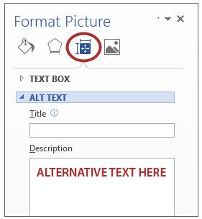

# Heading Styles

***Create a uniform heading structure through use of styles in Word.*** This allows screen readers to navigate a document and improves accessibility for everyone.

# Adding and Editing Headings

1. Select the text and ***choose the appropriate style*** under ***Styles*** on the ***Home*** tab. (e.g.,

"Heading 1")

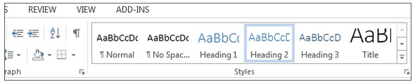

# Columns

When creating columns, ***always use true columns,*** not columns created by hand with the ***Tab*** key.

# Creating Columns

1. Click the ***Layout*** tab on the ribbon.
2. Select ***Columns*** under ***Page Setup*** group and choose the ***appropriate number of columns.***

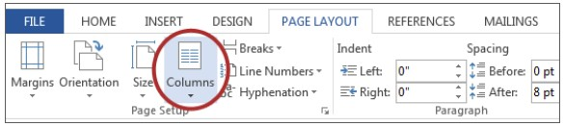

# Lists

**Creating Lists**

1. Select the ***Numbered List*** or ***Bulleted List*** option on the ***Home*** tab, under the ***Paragraph*** group.

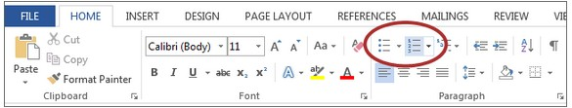

# Links

Word ***automatically creates a hyperlink*** when a user pastes a full URL onto a page. These may not make sense to screen reader users, so ***more information is needed.***

# Adding Hyperlinks

1. Select the text you want linked, right click, and select ***Hyperlink.***
2. Make sure the text in the ***Text to Display*** field is a meaningful description and type the link URL in the ***Address*** bar.

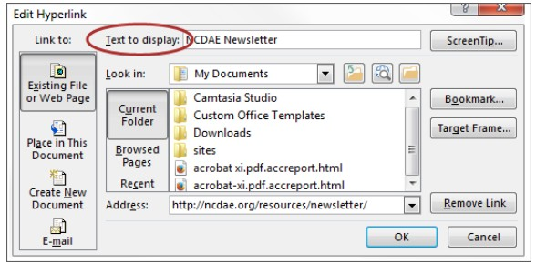

# Data Tables

Accessible tables need a ***clear table structure*** and ***table headers*** to help guide a screen reader user.

# Creating Tables

1. Select the ***Insert*** tab on the ribbon, then select ***Table > Insert Table.***

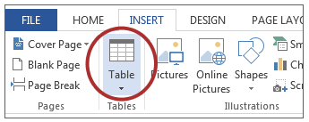

1. To add table headers to the first row, select ***Table Tools> Layout*** on the ribbon, then choose the ***Repeat Header Rows*** option in the ***Data*** section.

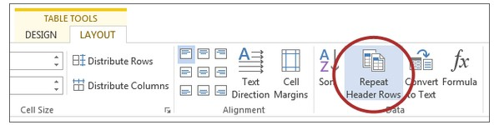

Options in the ***Design*** tab may be used to change appearance but will not provide the necessary accessibility information.

# Accessibility Checker

Word includes an accessibility resource that ***identifies accessibility issues.***

1. Select ***File> Info.***
2. Select the ***Check for Issues*** button and choose ***Check Accessibility.***

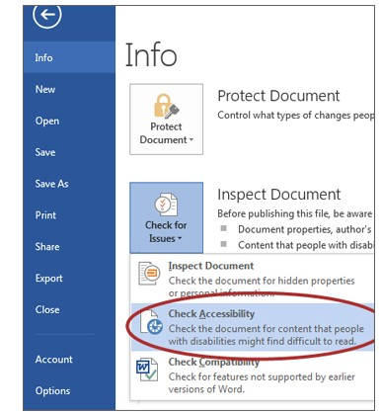

1. The Accessibility Checker task pane will show ***accessibility errors, warnings, and tips*** on how to repair the errors. Select specific issues to see ***Additional Information*** at the bottom of the task pane.

# Other Principles

Ensure that font size is sufficient, around ***12 points.***

Provide ***sufficient*** contrast.

Don't use color ***as the only way*** to convey content. Provide a ***table of contents*** for long documents.

Use ***simple*** language.