# Creating Accessible PDF’s Using Adobe Acrobat Pro

It is important for faculty to learn the steps to create accessible PDF’s. This ensures students with vision or reading impairments who rely on text-to-speech software access to course readings. Software programs such as Adobe Acrobat/Professional have Optical Character Recognition (OCR) capabilities to create an accessible PDF. Adobe Acrobat Professional is capable of converting many different types of files into an accessible PDF. If you have a document scanned as a GIF, JPEG, PNG, TIFF, or Microsoft Office file, any of these can be made accessible for your students (Free trials of this program are available online. Ask IT if you have this available on your campus).

1. Open a scanned PDF document in Adobe Acrobat X Pro.

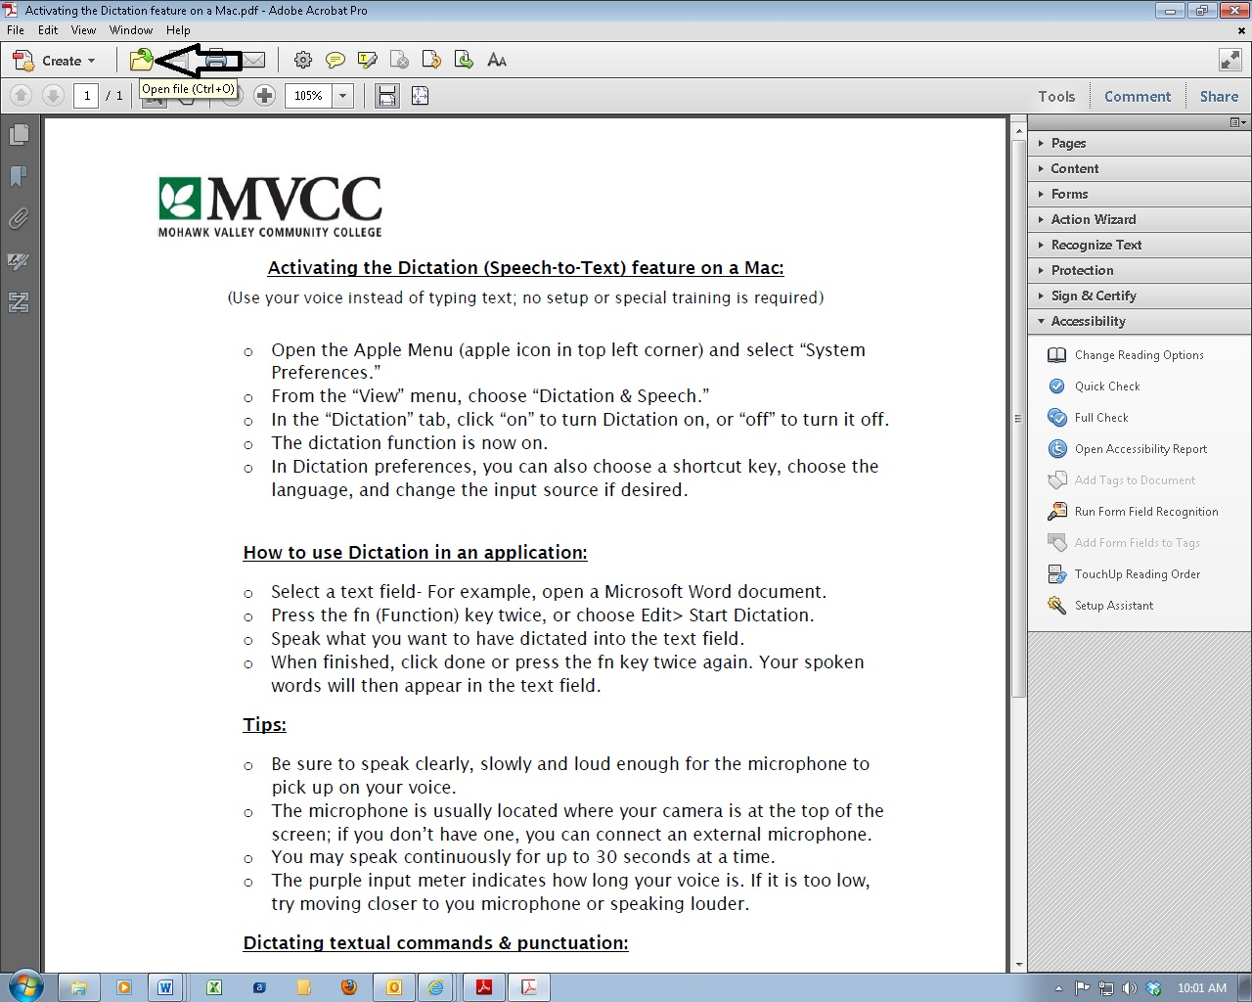

Click the yellow file button at the top to open the file

Find the file you want to convert and open it

## 2. In the top right hand corner, Click on “Tools”

In the menu, select the fifth option down, “recognize text” then select “in this file” and select “okay” if a box pops up. It will scan through the text and convert it so that it can be highlighted and read by a screen reader.

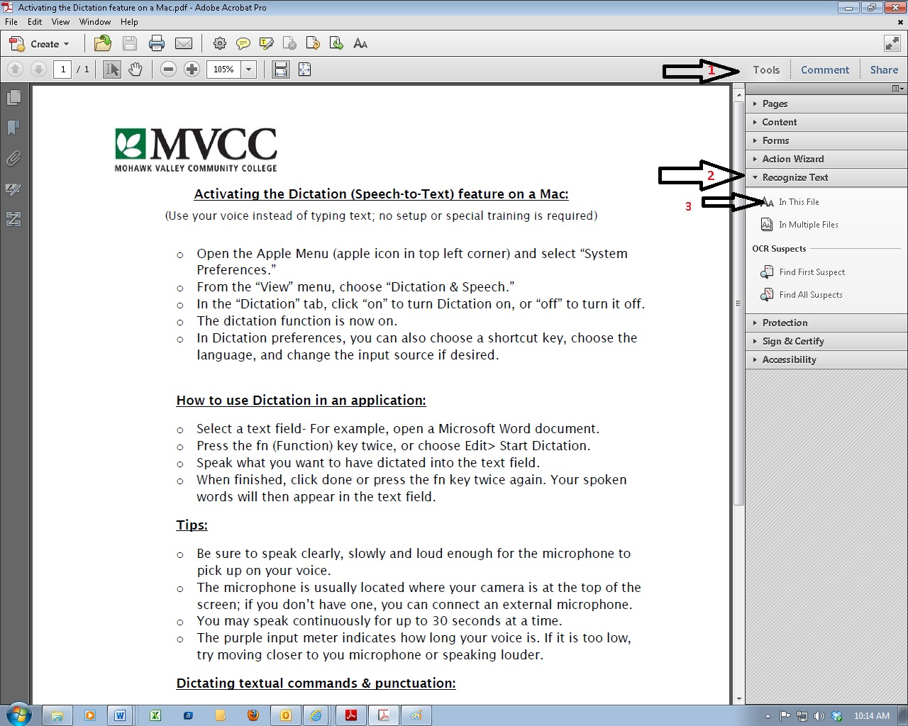

## 3. To correct any other PDF’s Accessibility concerns

In the Tools drop down menu, select the eighth option down, “Accessibility”. Choose “Full Check” to provide an accessibility report and follow the directions that are provided in the report.

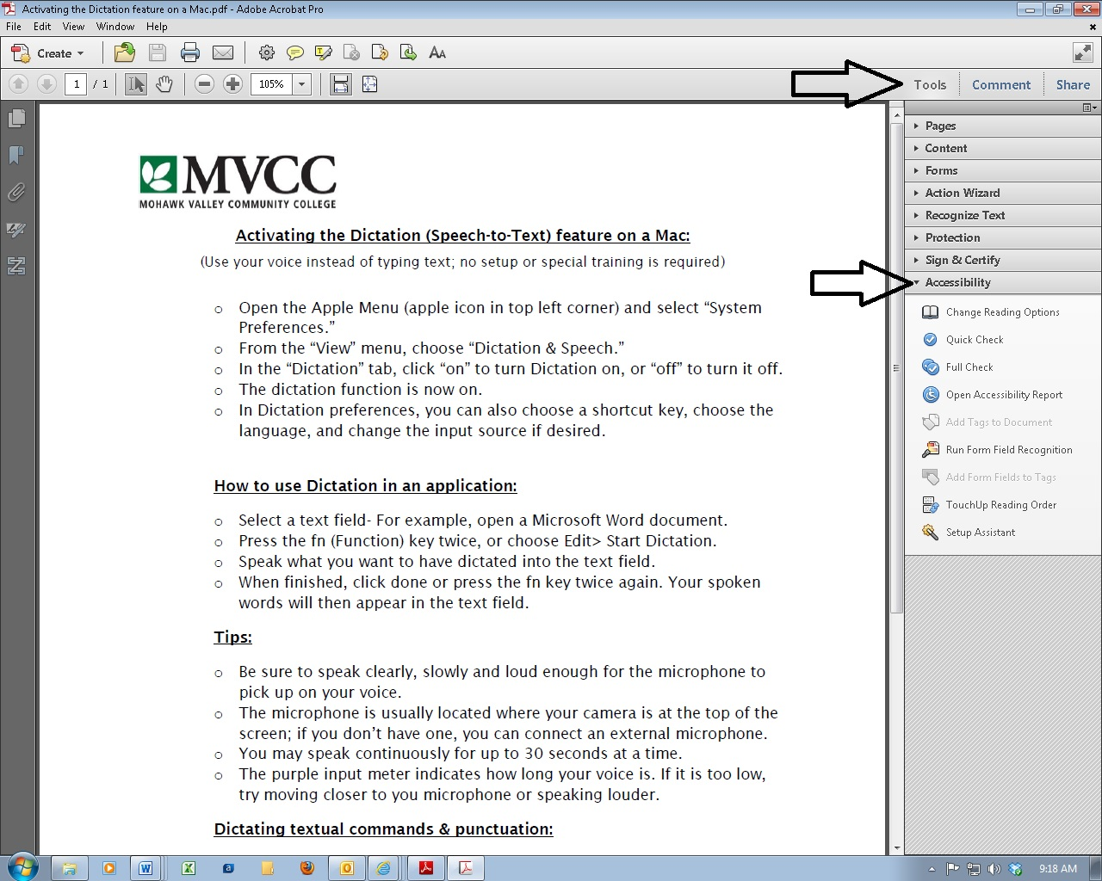

## 4. Don’t forget “SAVE AS”

Once it is done scanning, you will need to select “file,” “save as,” and select “PDF”. You must replace the existing file. Now when you open the PDF document in the reading software, it can be highlighted and read by a screen reader

## 5. Other information:

Keep in mind that if the original scan is of poor quality, the OCR programs will not be able to decipher the words and the document will not be read aloud correctly.

Some, though not all, PDFs downloaded from online databases, journals, or publishers may already be in an accessible format. Test the file by following the steps above, “How to Test PDF’s Accessibility”. If the document can be read aloud, you may not have to run an OCR scan.

For further information please go to the Adobe Pro Version X –accessibility info Link:

<http://www.adobe.com/accessibility/products/acrobat/training.html#10>